**Phase 4: Low fidelity prototype**

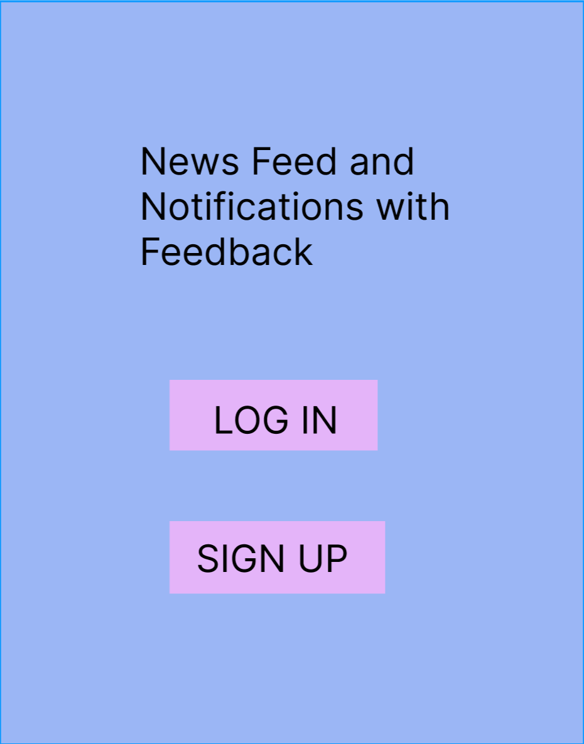

LOGIN

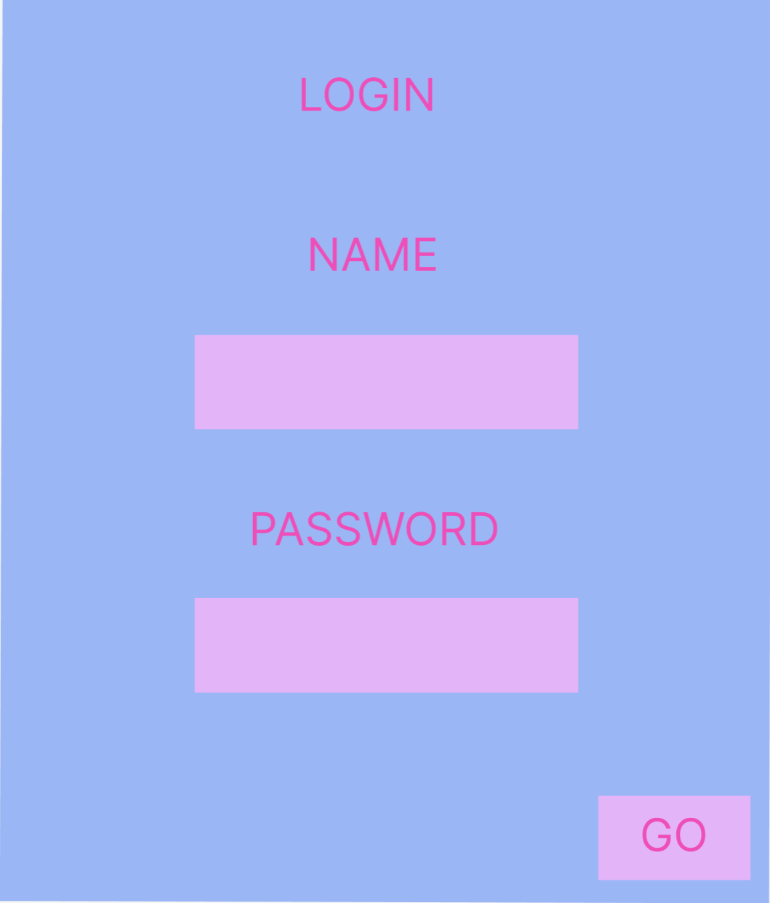

CREATE AN ACCOUNT with a specific role

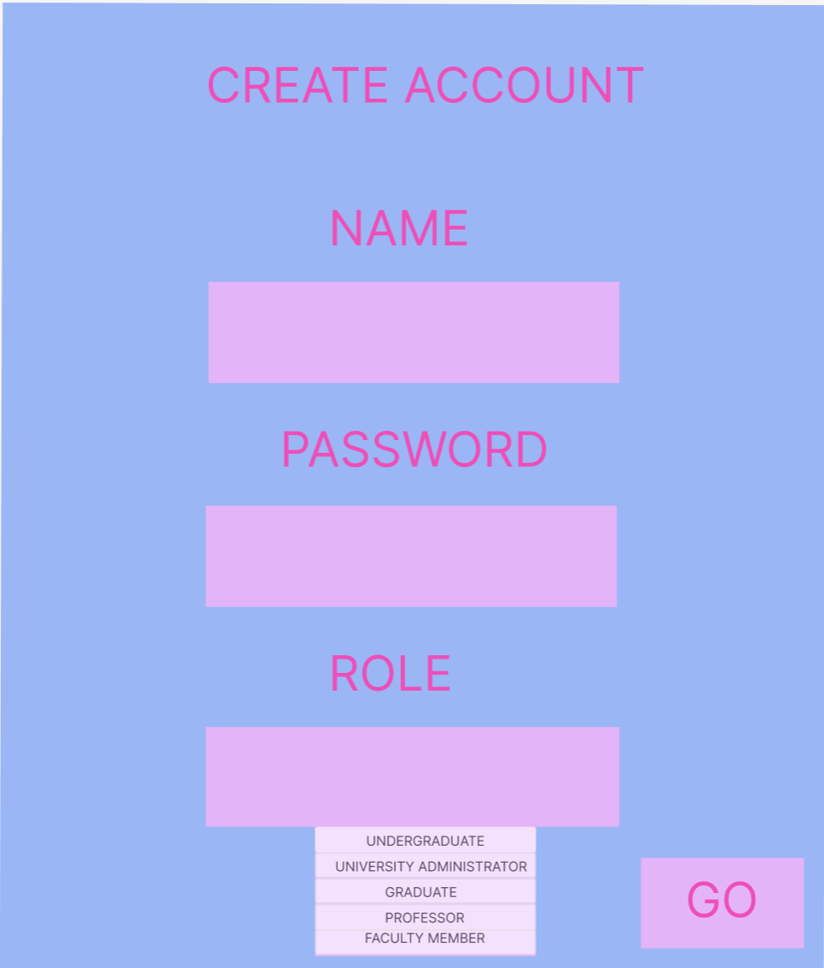

DASHBOARD FOR ADMIN:

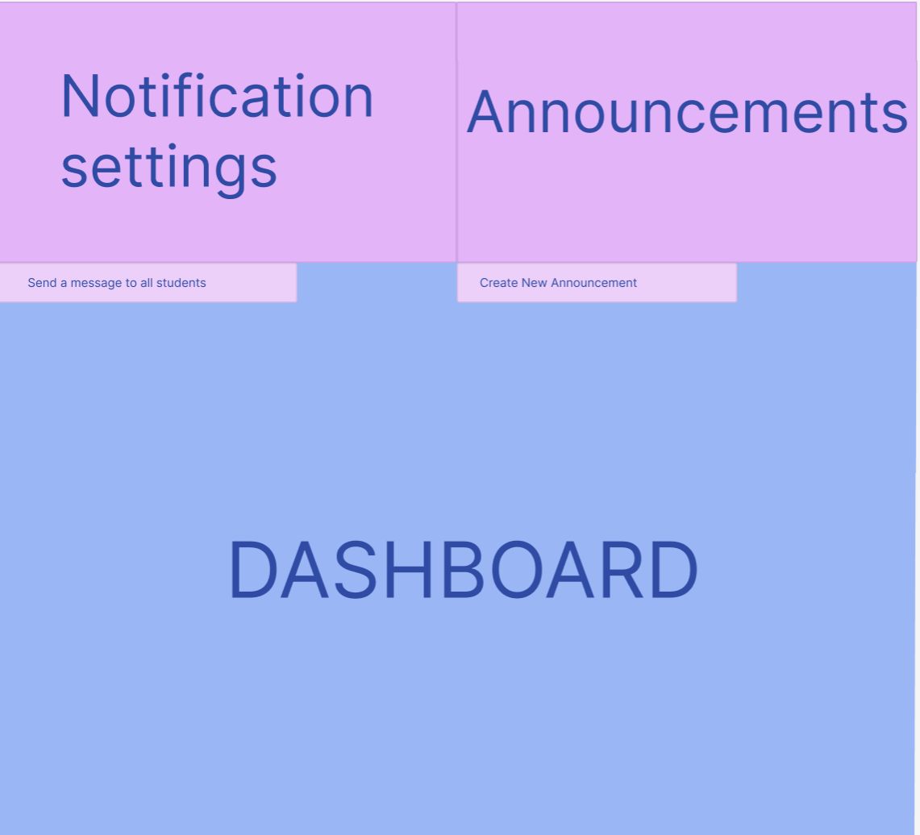

**TASK 1** – CLICK ON THE Send a message to all students(an option from the menu Notification settings)

(Sending a Notification to All Students)

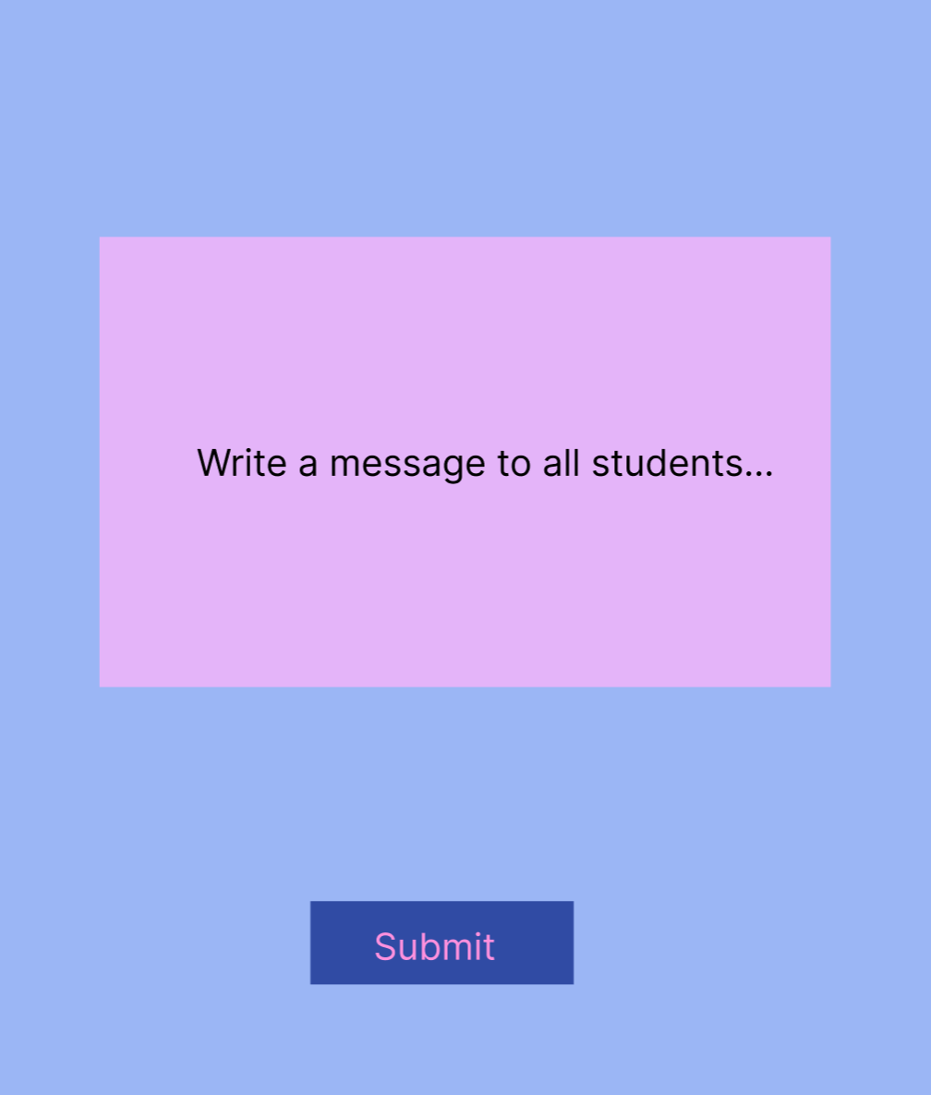

**TASK 2** – CLICK on the Create New Announcement(an option from the menu Announcements)

(Posting a University Event Announcement)

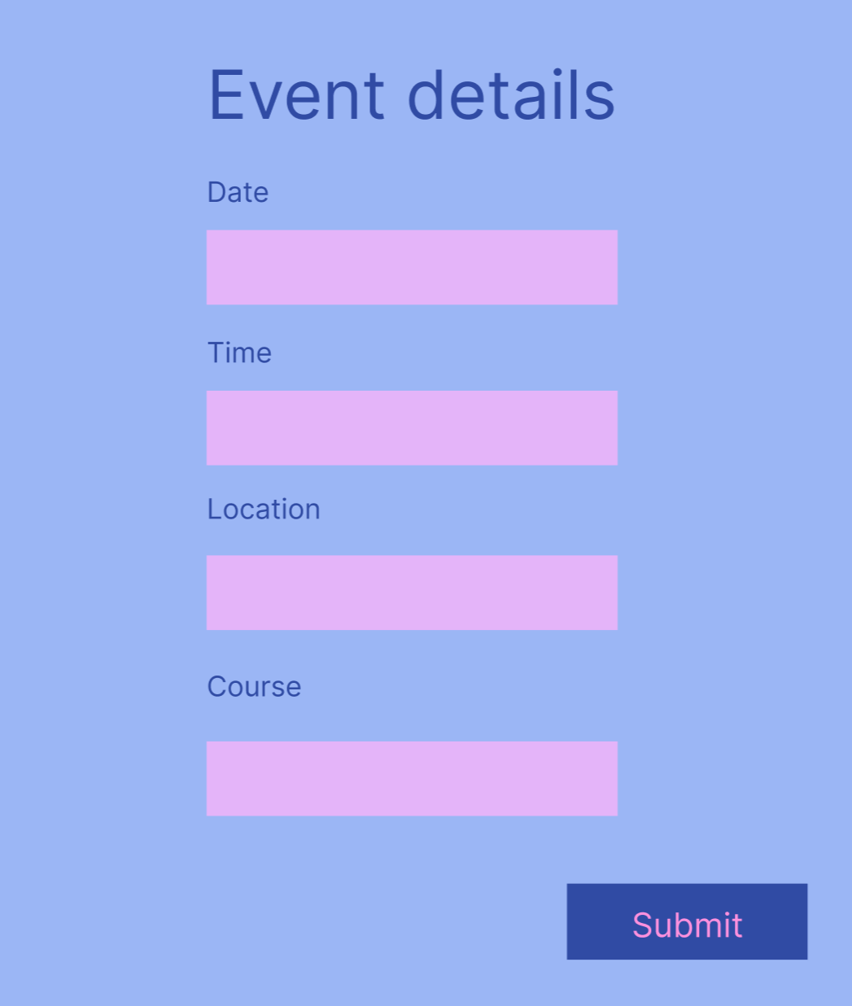

DASHBOARD FOR FACULTY MEMBER:

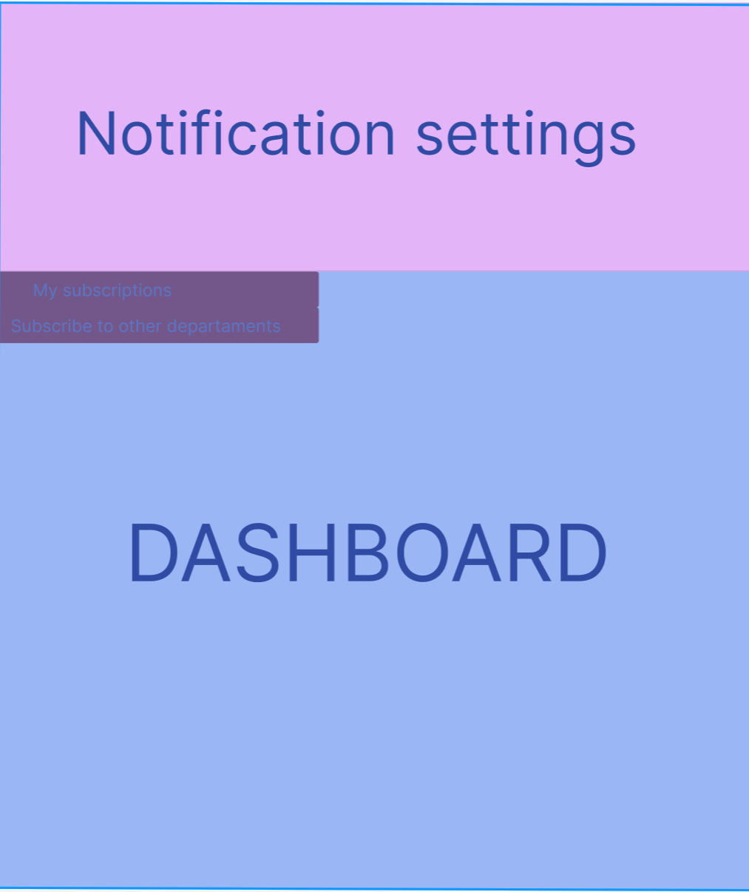

**TASK 3** – CLICK ON THE my subscriptions or subscribe to other departments

(Subscribing to Department Notifications)

Subscribe to other departments –

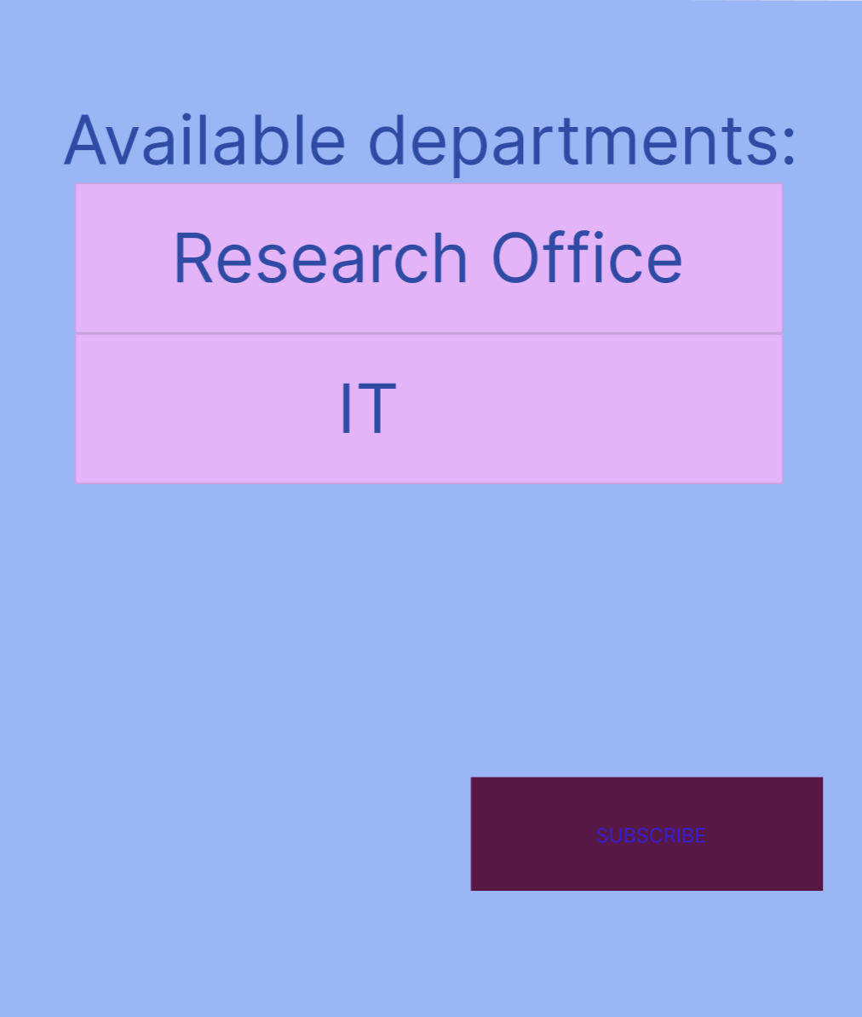

DASHBOARD FOR PROFESSOR:

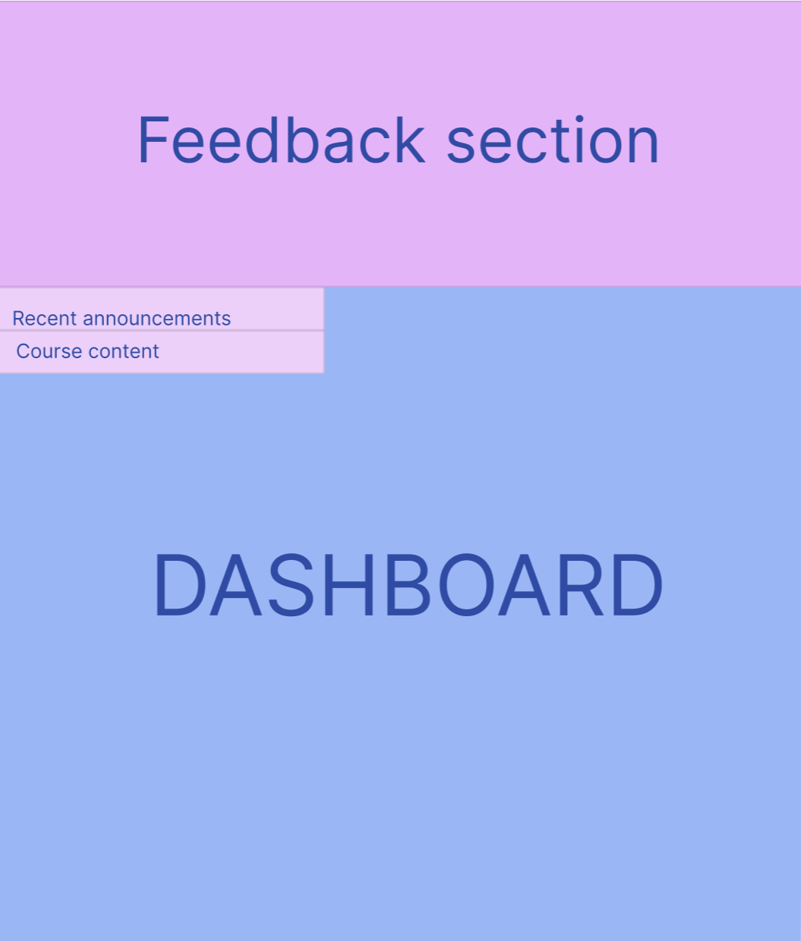

**TASK 4** – CLICK ON THE Recent announcements or Course Content (type of feedback from students)

(Reviewing Feedback from Students)

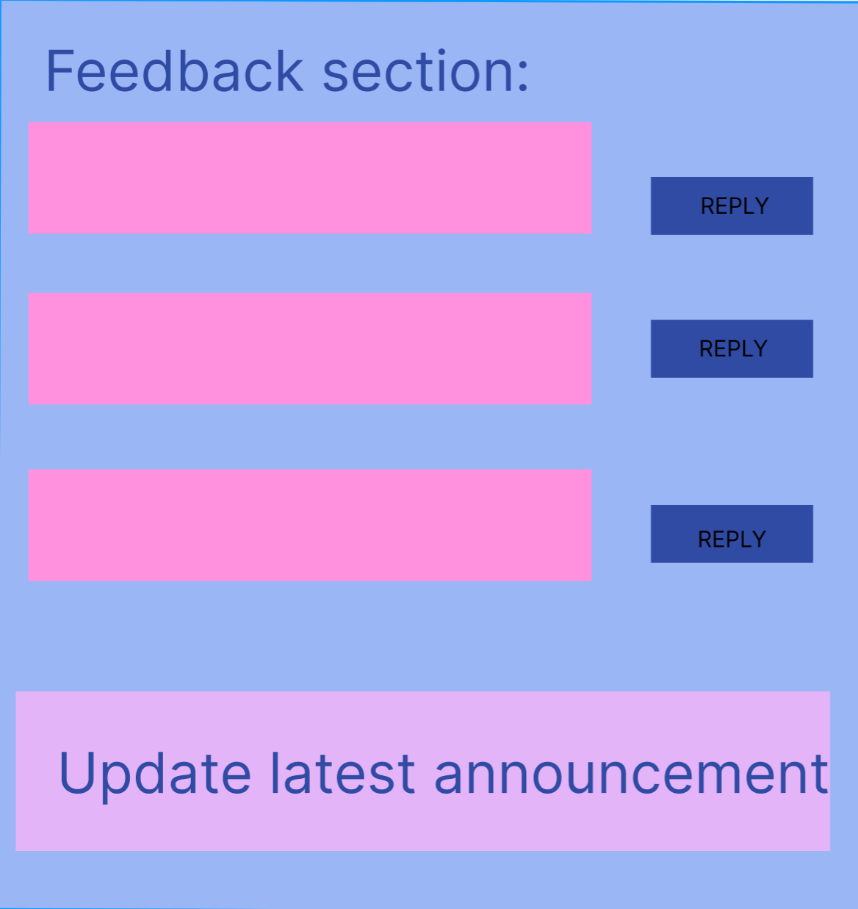

DASHBOARD FOR UNDERGRADUATE:

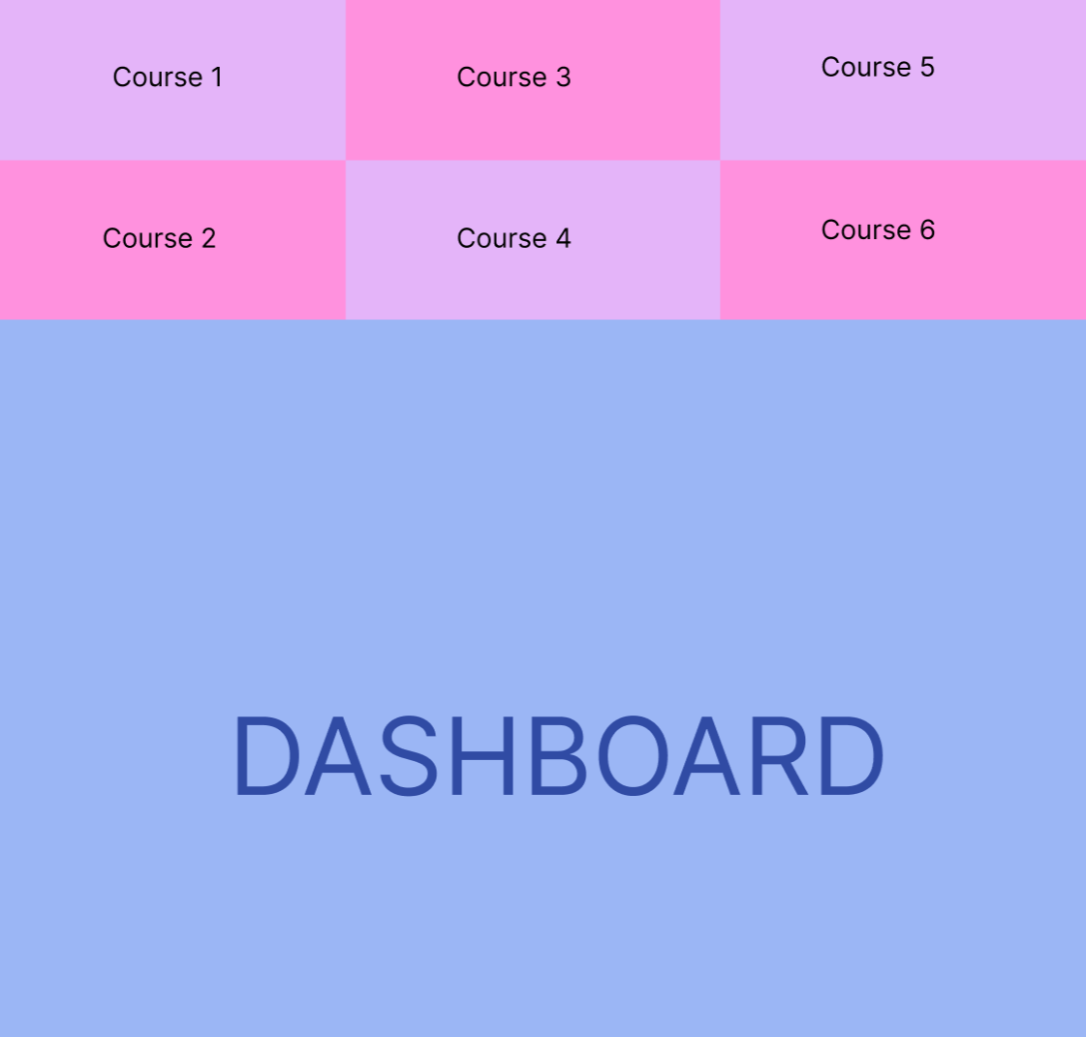

**TASK 5** – CLICK ON any course (courses may be added in the mean time for the undergraduate student – he/she can click any of them to see details about them)

(Viewing Course Announcements)

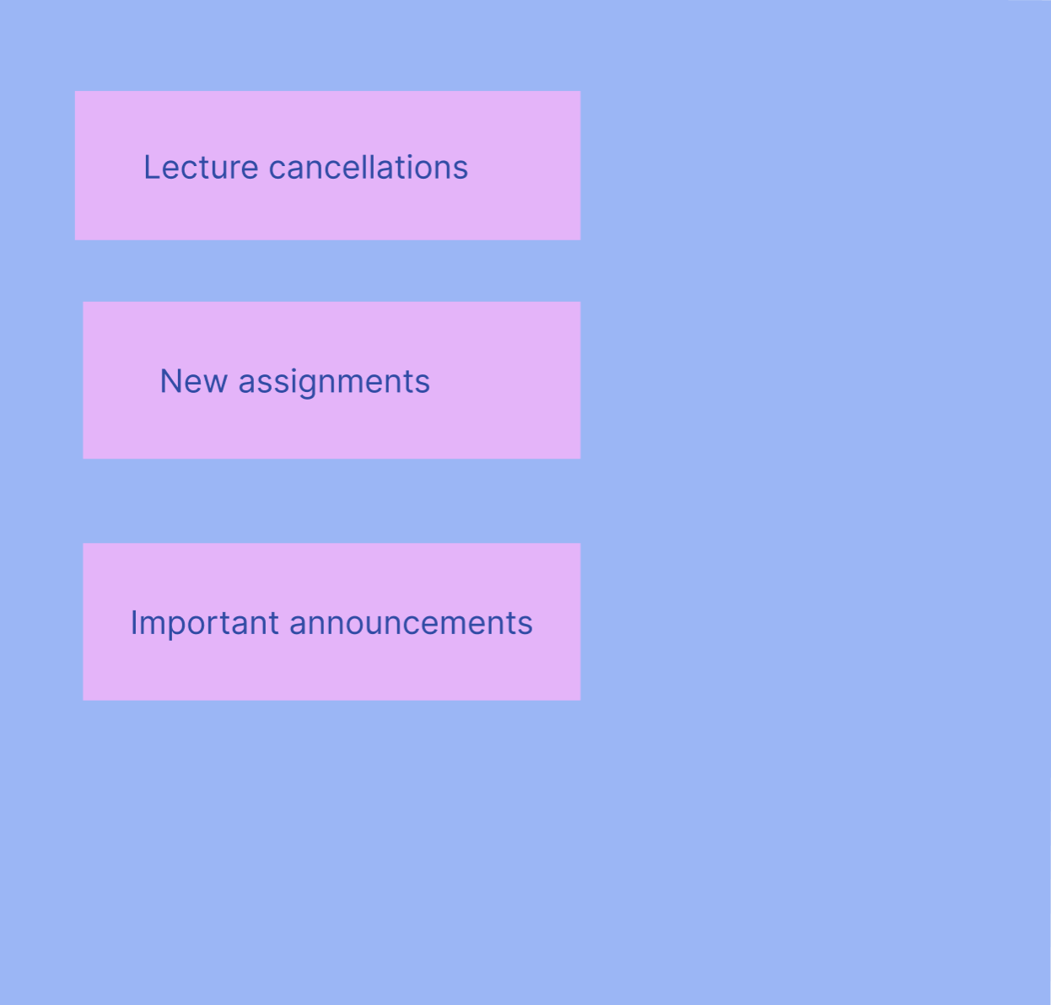

Clicking on the ,,Important announcements’’ button will show the latest 5 announcements made by the university administrator for that course.

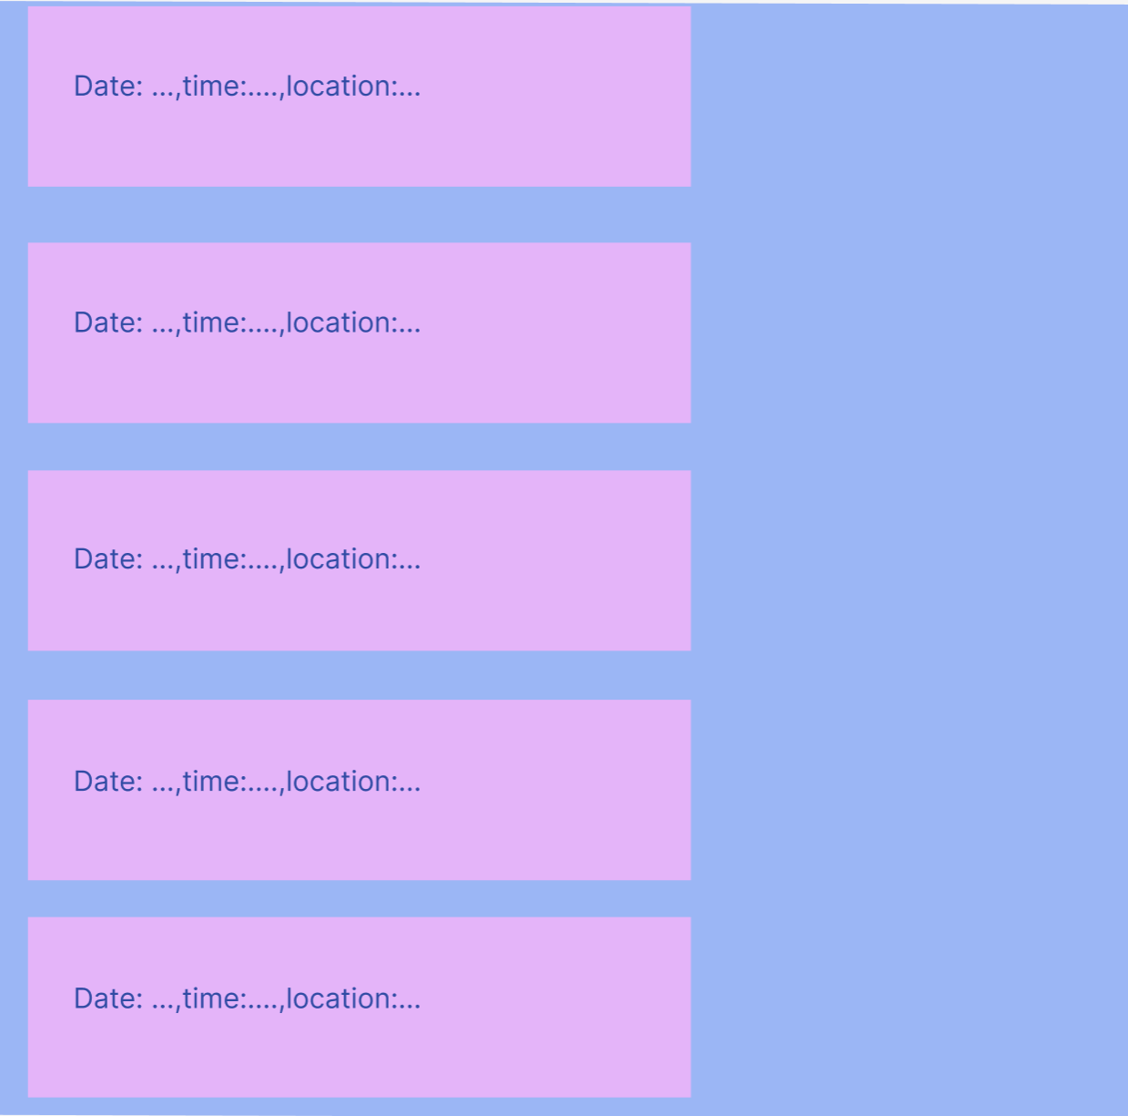

DASHBOARD FOR GRADUATE: CLICK ON the see notifications or set preferences

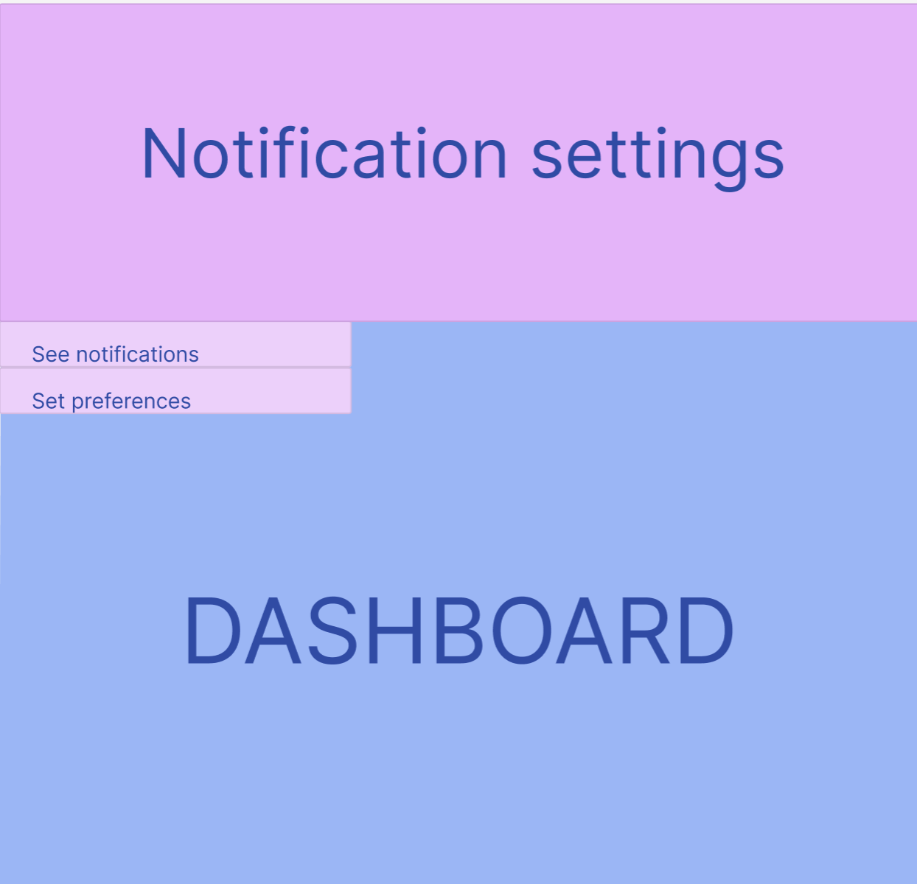

**TASK 6** – clicking on the set preferences

(Opting Out of Notifications for Specific Events)

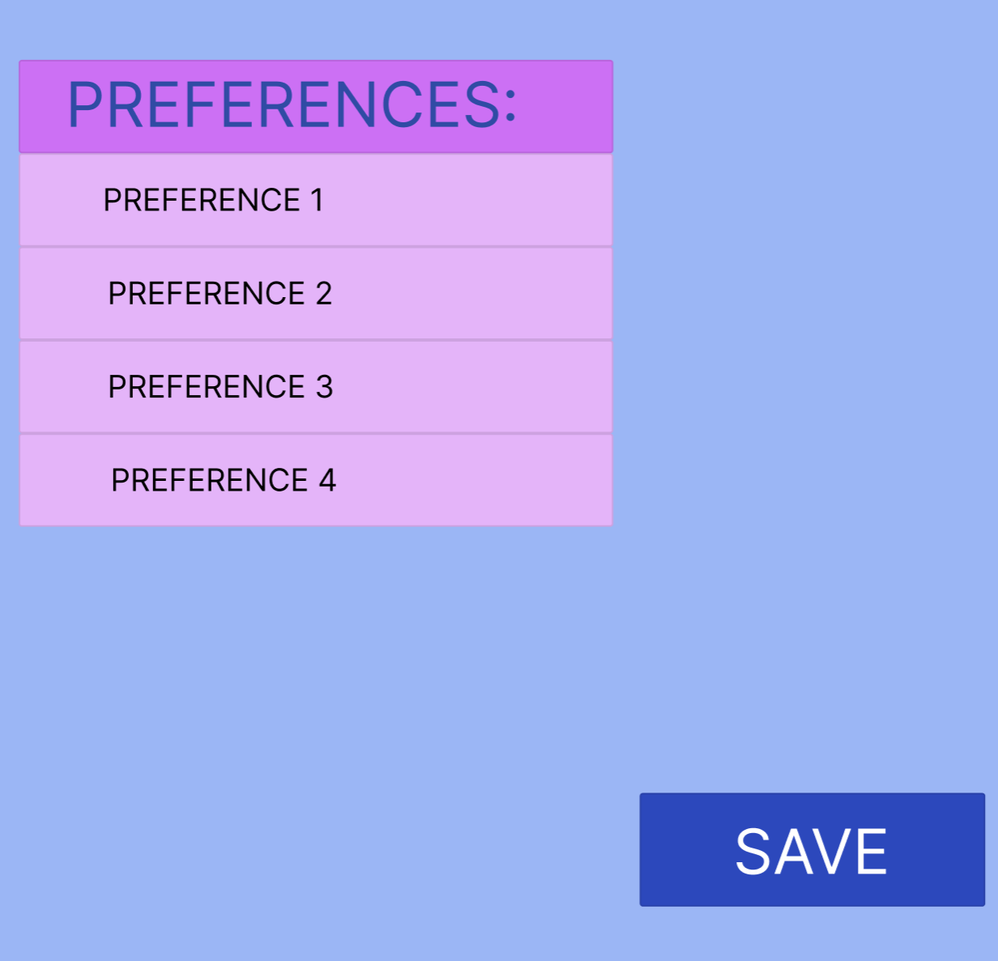

**Phase 4a: Examples of scenarios for user tasks**

**Task 2 –** One user scenario, the administrative staff logs in, and is redirected to their respective dashboard. In the dashboard there are present two options – the notification settings option and the announcements option.

For the notification settings, a menu is shown that has ’’send a message to all students’’ and for the announcements, a menu is shown that has ’’create new announcement’’.

The admin clicks on the ,,create new announcement’’ , creating a new page called ’’Event details’’ where a new event can be added. The event has a time, date, location, course. The admin fills these fields and then presses submit for a new event to be added.

This event can be viewed by all undergraduates in the ,,important announcements’’ section from that respective course.

**Task 5 –** A second user scenario, the undergraduate logs in, and is redirected to their respective dashboard. In the dashboard there are courses presented, the courses the user studies.

If a user select a course, a new page is created with lecture cancellations, new assignments, important announcements

By clicking on the important announcements button, the last 5 made announcements by the admin are shown for the respective course with their date, time, location.